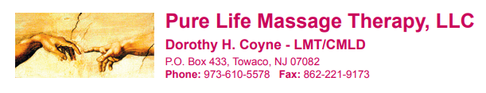

INFORMED CONSENT FOR BREAST MASSAGE

When the treatment of sensitive areas are indicated during the course of a massage therapy treatment, it is important that you, the client, fully understand the nature and purpose of the treatment. In addition to our discussion about the treatment, this written consent form will act as a record of that discussion. If you have any questions, either during our discussion or while completing this form, please do not hesitate to ask.

I, __________________________________________ (patient’s name), am voluntarily wishing to experience a session of breast massage, for the purpose for which is intended, healthy breast, recovery from surgery, scar improvement and/or medical breast massage.
I have discussed the treatment and/or treatment plan with _______________________________ (therapist’s name).
During this discussion, the benefits, risks and side effects, areas to be treated, positioning and draping (covering) to be used have been explained to me. I have had the opportunity to ask questions about the above information and I know that I can ask any questions that I may have, as a result of the treatment or further discussion, at a later date.
As with any other part of the massage therapy treatment, if at any time I feel uncomfortable for any reason, I will ask the Therapist to cease the massage and the Therapist will end either the breast massage or the treatment.
I understand the nipples and areolas of my breast will not be touched at any time during the treatment.
There are various levels of comfort in receiving breast massage. I am checking the statements that I feel comfortable with:
______ I would like the Therapist to demonstrate the breast massage technique for me while wearing a T-shirt.
______ I would like to remain clothed or draped and have the Therapist work with me through clothing or draping: __________Clothed _________Draped
______ I am comfortable having the Therapist work under the draping with the hands directly on the breast while performing massage.
______ I am comfortable having the Therapist work with the hands directly on the uncovered breast while performing massage.

I understand that I can alter or withdraw my consent for this treatment and/or treatment plan at any time during this or any other treatment.

Client Signature: ________________________________________ Date: _______________________
Massage Therapist Signature: ______________________________ Date: _______________________

In the event of a complaint or issue with law enforcement this form can be mailed to or filed on line:
New Jersey Board of Massage & Bodywork Therapy
Attn: Executive Director
P.O. Box 45048
Newark, NJ 07101
973-503-6520
http://www.njconsumeraffairs.gov/mbt/pages/regulations.aspx

